Artemis-I Operation Manual (HW revision -, SW V0.2+)

10/22/2024
Joe Haas, KE0FF

The Artemis-I is a PLL synthesizer based on the TI LMX2594 PLL chip. It utilizes a Microchip ATTINY-3217 microcontroller to configure the synthesizer registers via a serial interface. The following lists the major specifications of this synthesizer:

Frequency range: 4000 MHz to 15000 MHz (operation as low as 2250 Mhz with reduced output)
Output level: at least +10 dBm at 8000 MHz
Typical Phase Noise @ Fc = 4000 MHz: <TBD>
Typical Phase Noise @ Fc = 15000 MHz: <TBD>
Reference: 25.0000 MHz, on-board
External reference selected by de-soldering and moving a chip capacitor and may range
from 5 MHz to 1400 Mhz, 0.2 to 2 Vpp (-1 dBm to +19 dBm), Zin = 50Ω
Power supply: +5Vdc, 400 mA (heatsink required for Artemis board)
Communications: TTL UART com, 9600 baud, N81
/MUTE input: GND true, 3.3V compatible, on-board pull-up, GND to mute output
Frequency select inputs: 5 bit, binary, GND true, 3.3V logic
Primary connection: 16 pin ribbon header. Connector and cable not supplied. Connector P/N: TE/AMP 1658622-3, Ribbon cable, 16 conductor, 0.05” spacing, any vendor, length as needed (less than 12” recommended).
MCU PGM connection: Atmel UPDI programming via 16 pin connector or optional 6-pin
programming connector

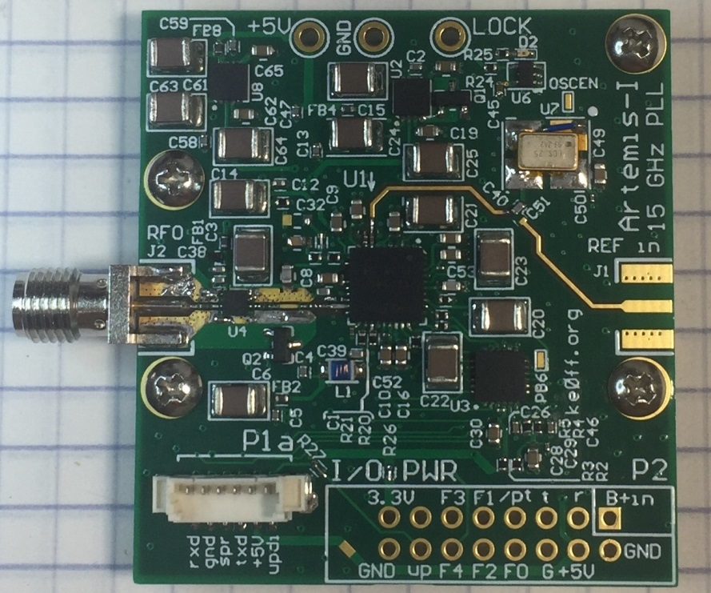
Figure 1. Artemis-I PLL Synthesizer
Operation

The Artemis operates from a +5Vdc, 400 mA supply. A heat-spreader/heat-sink is required for reliable operation (see Appendix for details). All power and control signals for normal operation are available at the main connector, P2.

P1 Pinout
UPDI 1 Note: See the “SiLabs/Tiva/ATtiny
+5V 2 Programming Guide” (see the bibliography
DBUG_TXD 3 section of this document for a link) for
SPARE 4 more information about this connector.
GND 5
DBUG_RXD 6

P2 Pinout
† +Vin (n/c) 1 2 GND
DBUG_RXD (TTL) 3 4 +5.0Vdc (400mA)
DBUG-232 TXD (TTL) 5 6 GND
/MUTE 7 8 FSEL0 (LSD b0)
(LSD b1) FSEL1 9 10 FSEL2 (LSD b2)
(LSD b3) FSEL3 11 12 FSEL4 (MSD b0)
n/c 13 14 UPDI
+3.3V (out) 15 16 GND

Note: All logic signals are 3.3V logic and will NOT tolerate higher voltage logic
† Bottom side pads facilitate external power applied at P2-1 to be routed to a 5V regulator allowing a centralized interface at P2.

Frequency Selection (Channels)

The Artemis functions as a 32 channel (only 4 channels are currently supported in SW V0.2) user-programmable frequency source. When /MUTE is open, the channel data represented by the binary code presented at the 5 FSEL inputs is transferred to the PLL. Each channel consists of 80, 16-bit registers that are transferred to the LMX2594 when the channel is selected. These registers comprise the entire register set of the LMX2594 and allow for complete control of the PLL functionality. Refer to the LMX2594 datasheet for additional information regarding these registers.

It is recommended that users utilize the TICSPro evaluation software provided by Texas Instruments when defining a register set for a particular channel definition. From this software, the contents of the registers can be exported and transfered into the Artemis MCU firmware. Programming the channels currently requires reprogramming of the MCU application and covered in a later section of this document.

The 5-bit logic inputs use the pull-up feature of the ATTINY MCU to allow the PLL channel to be selected by applying GND (0V) or open (>+2.5V) levels to the FSEL inputs. To switch channels, simply apply the desired bit pattern (using GND true logic) to the FSEL[4:0] inputs. Note: the MCU will change channels immediately upon detecting a change in the channel setting. Thus, if individual bits are changed over even just a few ms, it may be possible for the Artemis to select one or more unintended channels as the inputs settle.

“GND-True” means that a grounded bit = logic “1” and an open bit = logic “0”. Thus, channel 3 would be set by grounding FSEL1 and FSEL0, with all other FSEL inputs open (A DIP switch or GND common binary selector switch works well for this purpose).

/MUTE Function

If desired, the /MUTE input can be used to gate the PLL tone. This is useful for keying the output (for a beacon) or to mute the synthesizer for TX/RX transitions. Simply ground the /MUTE input to turn off the PLL, leave the input open to enable the output.

Serial Port

The Artemis MCU features a 3.3V TTL UART serial connection that can be used to program the MCU channel sets (future) or to provide real-time frequency control of the PLL. An elapsed time indicator and two temperature sensors are periodically reported to allow simple data-logging operations. The serial parameters are 9600 baud, 8 data bits, no parity, one stop bit. At power-on, an initialization banner message is sent by Artemis:

============
Artemis 2-15GHz PLL, V0.2, 4-chan
'?<ent>' for help, 09/23/24, de KE0FF
Artemis Start...
ETI: 1
<pll start>
Tone ON ETI: 1
CH set: 3
T0:323.4 K; T1:321.6 K; ETI: 3

Artemis Help:
0-3: set PLL CH
n: tone on
f: tone off
<ENTER>: display ETI(sec)/temp(K) stats
T0=regulator, T1=PLL
V: SW Version

The reset banner provides the software version and a brief list of version features. Primarily, this message is important for identifying the current software version, and verifying that the UART TX connection to the user terminal is working. Note: The banner message might change with newer software versions.

The serial commands available are as follows:

All commands are terminated with <CR> (ASCII 0x0d, <ENTER> or <RETURN> on most keyboards). Note: The ATTINY serial port does not echo characters entered from the host terminal.

Commands are 1 character, case sensitive:

?: List Command Help
Displays an abbreviated list of the available commands.

0 – 3: Select Channel
Performs a channel selection just as if the logic inputs were set. The FSEL logic inputs will be superseded until they change state.

n: Tone on
Enables the PLL output. Same as opening the /MUTE input. The /MUTE input is superseded until it changes state.

f: Tone off
Disables the PLL output. Same as grounding the /MUTE input. The /MUTE input is superseded until it changes state.

<Enter>: with no command, displays the PLL status message
An example message:

T0:323.4 K; T1:321.6 K; ETI: 3

T0 is the regulator temperature, T1 is the PLL temperature, the ETI is the number of seconds since power on. Temperatures are in Kelvins – subtract 273 to get the temperature in C.

V: Display software version

TICS Pro Software

The TICS Pro software is the easiest way to define a register set for the LMX2594 and experiment with different LMX2594 register settings. This software can be downloaded at no charge from the TI web site (see the Bibliography/Links section at the end of this document. Note, a log-in account is required, but is free to establish).

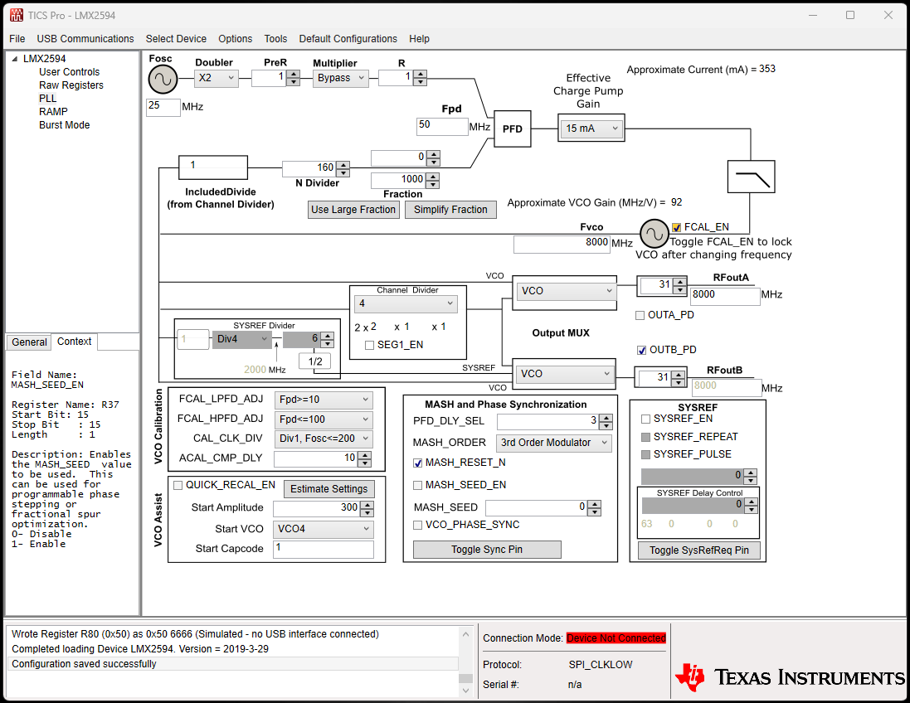

Figure 2. TICS Main Controls screen (selected by clicking “PLL” in the upper left pane).

Figure 2 illustrates the Main Controls screen of the software. Note: this software has the ability to communicate directly with the TI Evaluation board for the LMX2594. However, this functionality is not available with the Artemis board. Once the software is installed, the first step is to select the LMX2594 device as shown in Figure 3.

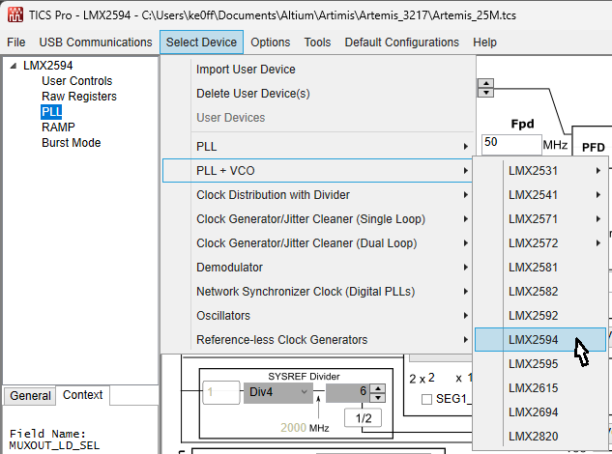
Figure 3. Device selection in the TICS Pro application

Next, set the reference frequency. It is a good idea to save the configuration to allow later retrieval and to guard against the TICS Pro software closing unexpectedly (it is known to do this on some machines). Under “File” choose “Save” and provide a meaningful filename (include the reference frequency, for example).

Also, be sure to confirm that the lock detect output is configured. This allows the LED to provide lock status:
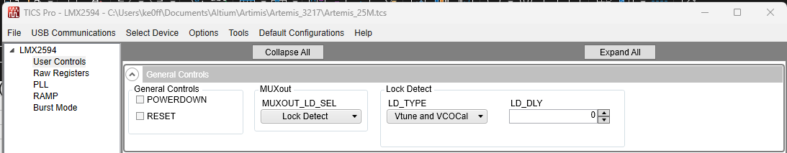
It is best to start with the default settings to the extent possible. The main items that must be filled in for a given frequency are as follows:

Reference Frequency: 25 MHz for the standard Artemis configuration (if a different reference is used, then that value is entered)
RFoutB: Enter the desired output frequency in MHz
OUTB_PD: Un-checked
RFoutA: do not adjust
OUTA_PD: Checked
RF Output Level: This is the unit-less numeric field next to the “RFoutB” text. 31 is the maximum effective setting. Values from 0 – 31 are considered usable.

The reference settings might require additional adjustment to allow fine-resolution frequencies to be selected. Refer to the LMX2594 datasheet and TICS Pro help files for explanations of the other fields on this screen.

The TICS Pro software updates the register settings in real time as the fields are updated. Settings that result in an illegal configuration or other known conflict will be indicated by “shading” of the respective setting field. The user may hover their mouse pointer over the field for a detailed message as to the nature of the problem and what should be done to correct it. The advice offered is generally acceptable.

Once a configuration is complete and there are no warnings displayed (the “FCAL_EN” check-box warning is for the TI Evaluation board connection and can be ignored), the register settings can be exported to allow them to be copied into the ATTINY source code (channels.c). Under “File”, select “Export hex register values”:

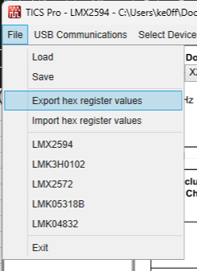
And provide a meaningful filename. This file is a plain-text file that has a list of the register addresses and values. Note that this list is not immediately usable by the ATTINY compiler. The desired data must be extracted first which is most easily accomplished by using Excel (2013 or later) or LibreOffice Calc (version 7.6 or later). An example file is included in the github repo, titled “register_extract.xlsx”. Follow the instructions in the spreadsheet for producing the output needed for the ATTINY compiler. The resulting data is copied and pasted into the “channels.c” source file, found in the ATTINY project “src” folder. Once all of the channels are copied into the source folder, the code may be compiled (F7) and loaded into the Artemis controller (green right-arrow).
Artemis Frequency Response

The LMX2594 can produce frequencies from 10 MHz to 15 GHz. That is over 3 decades of frequency range. However, the frequency response of the device varies over that range. In addition, the choice of buffer amplifier introduces its own influence on the frequency response of the Artemis output. In addition, cables and connectors introduce frequency dependent losses. The PMA2-183LN+ amplifier is specified to operate in the 4 to 15 GHz range, which covers the target range desired for the Artemis project (other synthesizers are available for the <4GHz range). However, the PMA2-183LN+ has some usable gain below 4 GHz, so it might be possible to use to as low as 2.25 GHz (no guarantees, however).

Figure 4 illustrates the Artemis response with the PMA2-183LN+. This plot represents a single sample, so it is for reference only. Performance at any given frequency must be verified by the user.

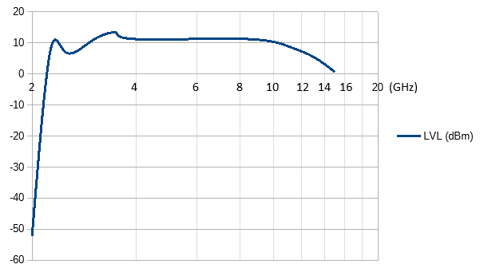
Figure 4. Representative frequency response of the Artemis synthesizer
MCU Programming Cable Connections

In order to program the MCU software or channel data using the MCU programming tools, the Microchip IDE compiler/debugger must be used with a suitable programming adapter. The programming adapter can be constructed with components available from DigiKey or Mouser. Instructions are found in the “SiLabs/Tiva/ATtiny Programming Guide” (see the Bibliography for a web link).

The debug adapter connects to P1 (see Figure 5). Follow the programmer instructions to compile and upload a new FLASH program to the MCU. Note: The 1-wire UPDI programming signal is also exposed on P2-14 making it possible to route the programming signal outside the PLL enclosure for ease of access. UPDI and GND are the only signals needed to connect to an external programming interface.

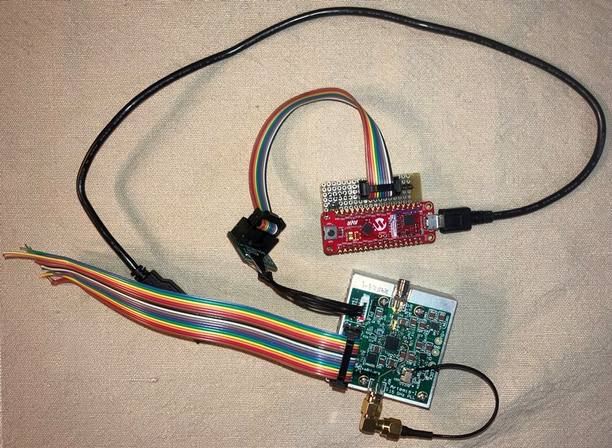
Figure 5. ATTINY programmer connection to the Artemis board

UART Connections

The Debug RXD and TXD connections (3.3V TTL) are available at P2-3 and P2-5, respectively. To exercise this option, a 3.3V TTL USB com port adapter must be used (Available on Amazon.com: DTech USB to TTL Serial 3.3V Adapter Cable TX RX Signal 4 Pin 0.1 inch Pitch Female Socket PL2303 Prolific Chip Windows 10 8 7 XP Vista (6ft, Black) : Electronics or other models that provide a UART COM port with 3.3V TTL logic interface).

Alternatively, the ATTINY CuriosityNano Programmer, described in the “SiLabs/Tiva/ATtiny Programming Guide” (see the Bibliography for a link) can be used as a USB COM port for the Artemis board.

Bibliography/References

- TICS Pro Software: https://dr-download.ti.com/secure/software-development/support-software/MD-xsZ2KP7U5k/1.7.7.5/TICSPro_1.7.7.5_23-Jul-2024.exe
- LMX2594 datasheet: https://www.ti.com/product/LMX2594?keyMatch=LMX2594&tisearch=universal_search&usecase=GPN-ALT
- Artemis github repo: https://github.com/ke0ff/artemis_pll
- Microchip Studio: https://www.microchip.com/en-us/tools-resources/develop/microchip-studio#Downloads
- Mini Circuits product page for the PMA2-183LN+: https://www.minicircuits.com/WebStore/dashboard.html?model=PMA2-183LN%2B
- SiLabs/Tiva/ATtiny Programming Guide: https://ke0ff.github.io/Orion/silabspgm.pdf
- Channel formatting spreadsheet: https://github.com/ke0ff/artemis_pll/blob/main/register_extract.xlsx
Appendix A
Installation and Application Notes

The Artemis mounting holes are sized for 2-56 screws (0.11” diameter clearance hole). Figure 6 illustrates the outline drawing of the Artemis including mounting hole locations. 8 screws and 4 standoffs are included with the Artemis kit. Replacement screws and standoffs may be obtained from McMaster-Carr (www.mcmaster.com) or other hardware supplier:

Screws, 2-56 x 0.250” (McMaster PN: 91772A077), QTY 4
Spacer, #2 x 0.0625” (McMaster PN: 92510A378), QTY 4

A heatsink is required for proper operation of the Artemis board. Figure 7 illustrates the drill/mill template for the mating surface of the heatsink (the source and P/N are in the BOM, shown later in this document). This template is available as a 3D printable model on the Artemis github.com repo. There are provisions to accommodate an external 5V regulator on the heatsink (user provided). A good, ultra-low-noise design is recommended.

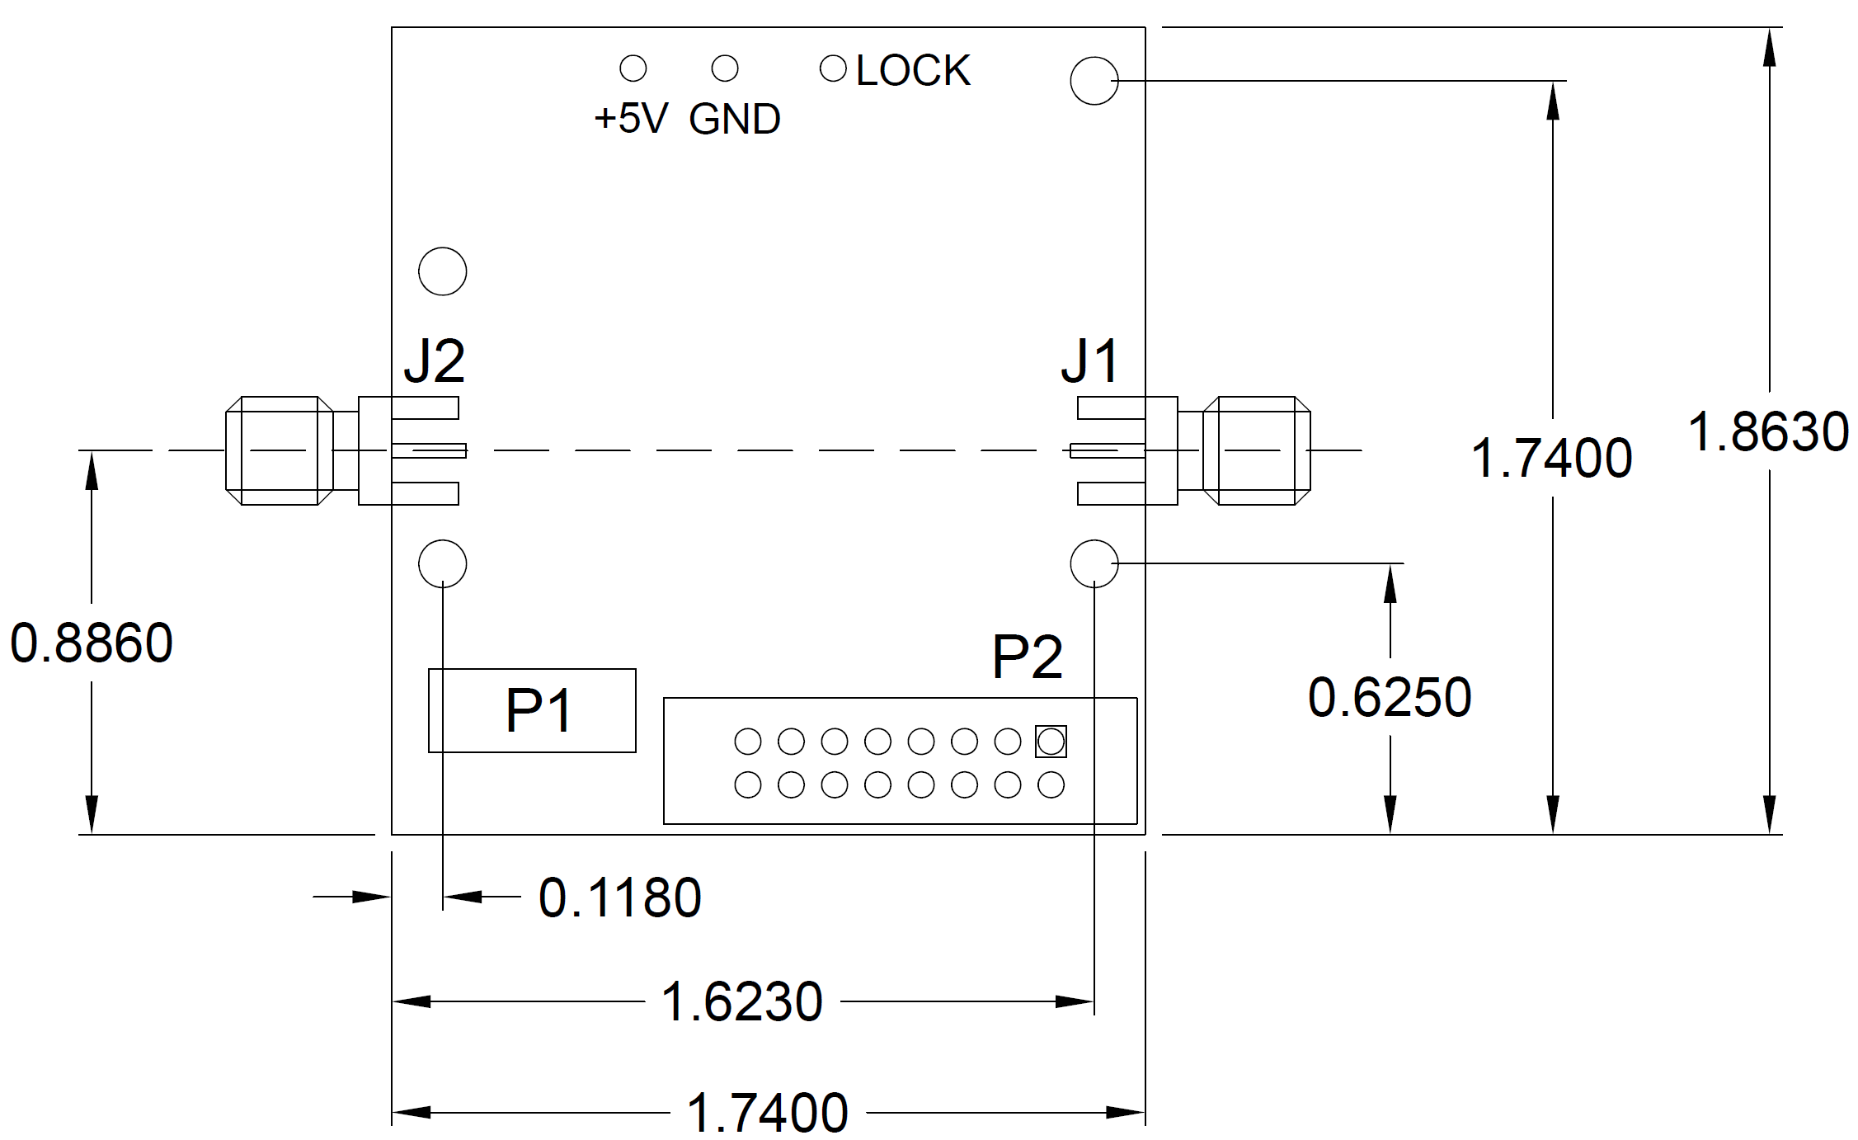
Figure 6. Artemis mechanical dimensions

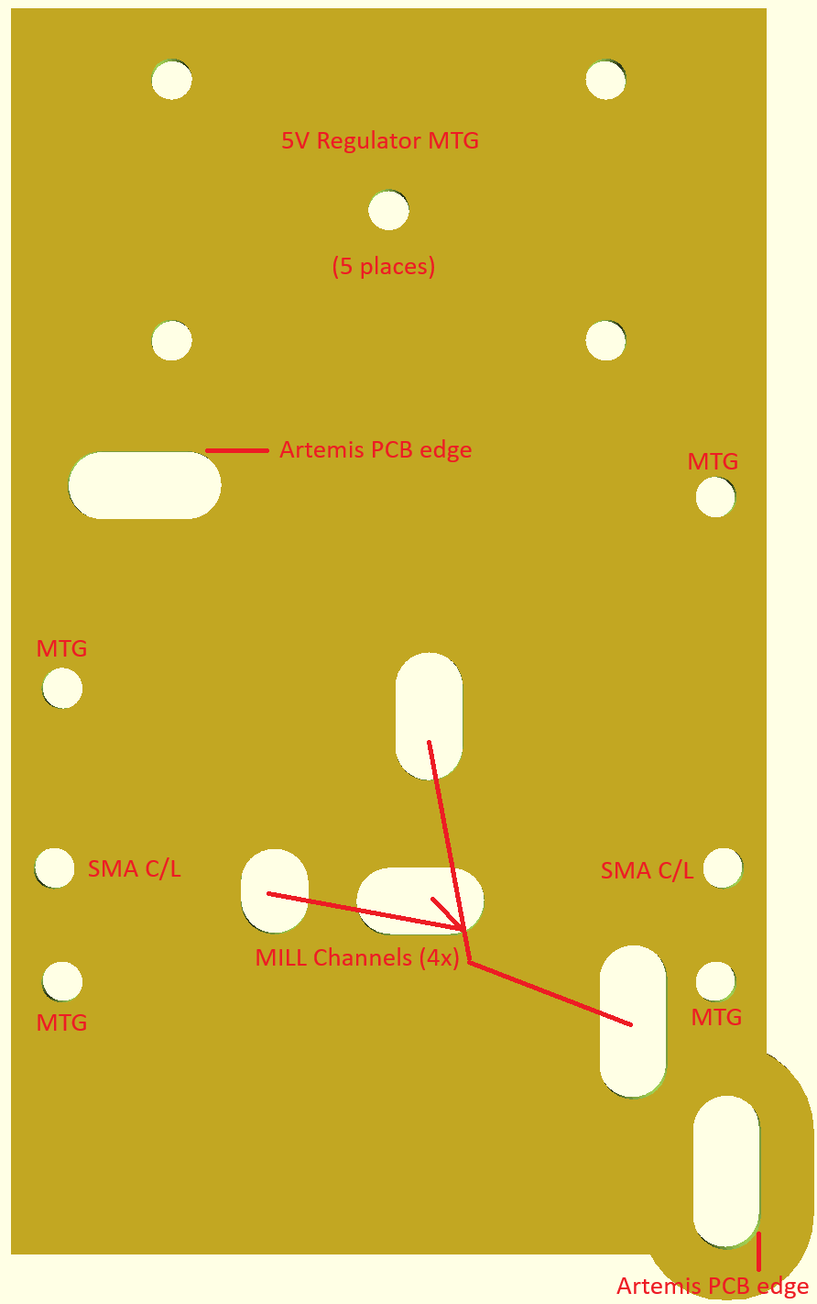

Figure 7. Artemis Heat-sink drill/mill template
MTG holes are 2-56 drill and tap, 0.3” deep
Center 5V regulator hole is 4-40 drill and tap, 0.3” deep
Mill channel depths to match bottom side components +20 mils

RF Filtering

The Artemis PLL is an excellent signal source with a very wide tuning range. The Artemis is suitable for a transverter or transceiver LO source, or a lab instrumentation source. It is also a popular debug tool for field testing receivers when roving.

For all of its flexibility, there is one thing that must be considered when using the Artemis: filtering is required to reduce the harmonic output of the PLL. For some output settings, the harmonic output can be as high as -16 dBc or more. For instrumentation applications, this may not be a serious issue. However, for communications transceiver applications, these spurs must be reduced to preserve signal purity and system performance. Generally, a suitable low-pass filter will have an Fc somewhat above the desired output frequency (to reduce pass-band attenuation) and a stop band that extends to at least 5Fc. At least 30 dB at 2Fc and 35 dB of stop-band attenuation at or above 3Fc is a good general purpose target for most applications. This will generally provide -45 dBc or better harmonic perfomance.

Small SMA filters, such as available from MiniCircuits, are easy to implement, and are not terribly costly – they simply attach to the Artemis output via an appropriate adapter. For LO and other mixer applications, reflectionless filters are recommended as these present a consistent input/output impedance even in the stop-band. However, these can be more difficult to find and implement, so they are not often an easy option. A buffer with high-isolation can be used after the filter if it is a good match to 50 ohms in the stop-band. This may also require an attenuator if the buffer produces too much signal for the mixer. The attenuator should follow the buffer if possible and should offer a good output match across the entire bandwidth of the mixer.

Filtering for wide bandwidth applications (about an octave of bandwidth or greater) is difficult to manage because the output frequency varies over the harmonic range of the lowest desired output. This means that a filter that is good for the lower frequencies will attenuate the higher frequencies and a filter optimized for the higher frequency will not provide sufficient attenuation to the 2nd harmonic at the lowe frequencies. In these cases, either a switched filter arrangement or a tunable filter, such as a YIG Tuned Filter (YTF), must be used. Both options represent a complicated compromise that will require considerable care and effort to produce.

Fortunately, most wide-band applications are geared towards instrumentation where other instruments that are part of the measurement suite might be expected to provide some semblance of filtering or other immunity to harmonics emitted by the Artemis reference source.

Appendix B
Schematic and BOM

Bill Of Materials

Qty | Designator | Description | MFR | MPN
4 | C1, C29, C31, C50 | CAP, MLCC, X5R, 0201, 25V, 10%, 0.1uF | Taiyo Yuden | GMK063BJ104KP-F
10 | C2, C4, C5, C12, C13, C47, C48, C56, C58, C59 | CAP, MLCC, C0G, 0402, 100V, 10%, 1000pF | Kemet | C0402C102J1GEC7411
3 | C26, C45, C46 | CAP, MLCC, X5R, 0402, 25V, 10%, 0.1uF | Murata | GRM155R71H104KE14D
2 | C27, C65 | CAP, MLCC, X7R, 0603, 50V, 10%, 1uF | Taiyo Yuden | UMK107AB7105MA-T
15 | C3, C6, C14, C15, C20, C21, C22, C23, C24, C25, C57, C60, C61, C63, C64 | CAP, MLCC, X7R, 1210, 50V, 10%, 10uF | Kemet | C1210C106K5RACTU
1 | C33 | CAP, MLCC, C0G, 0603, 100V, 10%, 1800pF | Murata | GRM1885C2A182JA01D
1 | C34 | CAP, MLCC, C0G, 0603, 50V, 10%, 0.068uF | TDK | VJ0603Y683KXACW1BC
1 | C35 | CAP, MLCC, C0G, 0603, 50V, 10%, 390pF | TDK | C1608C0G2A391K080AA
1 | C36 | CAP, MLCC, C0G, 0402, 50V, 5%, 1000pF | Murata | GRM1555C1H102FA01D
1 | C37 | CAP, MLCC, C0G, 0402, 50V, 5%, 100pF | Murata | GRM1555C1H101JA01J
1 | C38 | CAP, TANT, SMD, 0402, 0.33uF, 20V | ROHM Semi | TCTU1D334M8R
3 | C39, C44, C51 | CAP, MLCC, C0G, 0402, 16V, 10%, 10000pF | Murata | GRM1555CYA103GE01D
3 | C41, C42, C43 | CAP, MLCC, C0G, 0201, 16V, 10%, 0.1uF | Passives Plus | 0201BB104KW160
2 | C54, C55 | CAP, MLCC, C0G, 0201, 16V, 10%, 10000pF | Taiyo Yuden | MSASU063SB5103KFNA01
2 | C52, C53 | CAP, MLCC, C0G, 0201, 100V, 10%, 1000pF | Murata | GRM0335C1H102GE01D
13 | C7, C8, C9, C10, C11, C16, C17, C18, C19, C28, C30, C49, C62 | CAP, MLCC, X7R, 0603, 50V, 10%, 1uF | Taiyo Yuden | MSASU168AB7105KTNA01
1 | D1 | DIO, 50V, SHTKY, SMA | MCC | SS2150-LTP
1 | D2 | LED, 0402, GRN | Kingbright | APG1005CGC-T
1 | D3 | DIO, TVS, 15V, 500W | MCC | SMAJ16A-TP
1 | D4 | DIO, TVS, 5V, 500W, DIODE | Yageo | P4SMA6.8A/TR13
8 | FB1, FB2, FB3, FB4, FB5, FB6, FB7, FB8 | Bead, Ferrite, SMD, 80 ohm | Laird | MI0402K121R-10
2 | J1, J2 | CONN, SMA, EDGE | TE Connectivity | CONSMA003.062
2 | L1, L2 | IND, CHP, WW, 3.3nH, 0805 | Kyocera | L08053R3CEWTR
0 | P1 or P1a | CON, PICBLD, 1.25MM, 6POS (optional) | Molex | 53398-0671
1 | P2 | CON, DIP, 16 POS | 3M | D2516-6002-AR
1 | P2-mate | CON, IDC, 16 POS | 3M | D89116-0031HK
6 | P2-cable (per inch) | CBL, RBN, 16 POS | 3M | 3801/16
2 | Q1, Q2 | TRAN, PNP, 40V, 100mA, 4.7K bias | OnSemi | MMUN2132LT1G
1 | R1 | RES, CHP, 0402, 1%, 100ppm/C, 1 | Vishay/Dale | RCC04021R00FKED
9 | R10, R11, R12, R13, R14, R16, R18, R19, R24 | RES, CHP, 0402, 1%, 33 | Yageo | RC0402FR-0733RL
2 | R15, R17 | RES, CHP, RF, 0402, 0.1%, 50 | Vishay/Dale | FC0402E50R0BST1
1 | R2 | RES, CHP, 0402, 1%, 470 | Yageo | RC0402FR-07470RL
4 | R20, R21, R22, R23 | RES, CHP, 0201, 1%, 49.9 | Yageo | RC0201FR-0749R9L
1 | R25 | RES, CHP, 0402, 1%, 402 | Yageo | RC0402FR-07402RL
1 | R2a | RES, CHP, 0402, 1%, 49.9 | Yageo | RC0402FR-0749R9L
1 | R3 | RES, CHP, 0402, 1%, 4.99 | Yageo | RC0402FR-074R99L
2 | R4, R5 | RES, CHP, 0402, 1%, 3.60K | Yageo | RC0402FR-073K6L
4 | R6, R9, R26, R27 | RES, CHP, 0402, 1%, 0 | Yageo | RC0402FR-070RL
1 | R7 | RES, CHP, 0402, 1%, 18 | Yageo | RC0402FR-0718RL
1 | R8 | RES, CHP, 0402, 1%, 68 | Yageo | RC0402FR-0768RL
1 | U1 | IC, PLL, w/VCO, 7.3-15000 MHz, 300MHz REF | TI | LMX2594RHAT
2 | U2, U8 | IC, VREG, ULN, 3.3V | Analog Devices | ADM7154ACPZ-3.3-R7
1 | U3 | IC, MCU, SFF, 8b, 32Kb, 20MHz | MicroChip | ATTINY3217-MNR
1 | U4 | MMIC, AMP, E-PHEMT | Mini Circuits | PMA2-183LN+
1 | U6 | IC,GATE,2IN,AND,SNGL, | TI | SN74AHC1G08DCKR
ALT | U7 | IC, OSC, SMD, W_EN | Abracon | ASEMB-25.000MHZ-LC-T
1 | U7 | IC, OSC, SMD, W_EN | ECS | ECS-TXO53-S3-33-250-BN-TR
1 | PCB | PCB, Artemis-I, Rev - | ANY | Artemis-I
1 | THP1 | Pad, Thermal, 1”x1” | Laird | A15959-07
1 | HS1 | Heat Sink, 2”x3”, 5W – heatsinkonline.com | heatsinkonline.com | 253AS

